**AI :Task 3**

**(Knowledge Representation : Semantic Net & Frame)**

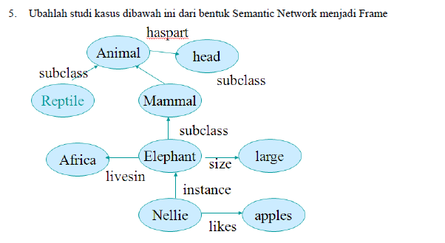

* Frame diagram

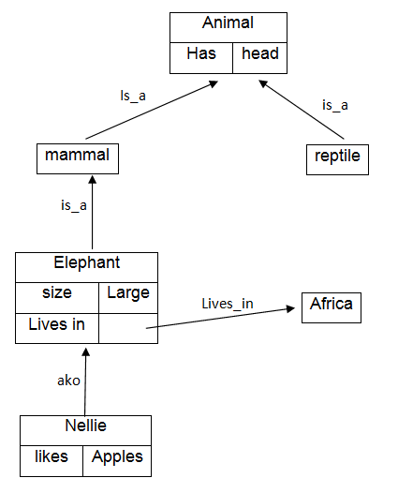

* Prolog